**Project meeting #2**

**Meeting Agenda**:

1. **Project Overview and Progress:**
   * Recap of first two weeks: Research on sensors, data gathering, and Figma design for five screens.
   * Current week’s focus: Interface development for the designed screens and research on sensor data types (Raspberry Pi, Smell sensor).
2. **Remaining Work for This Week:**
   * Development of the app's interface.
   * Continue research on data parameters from Raspberry Pi and the smell sensor.
3. **Next Week’s Focus (Week 3):**
   * **Bluetooth Connectivity**:
     + Implement pairing between Raspberry Pi and Android app.
     + Use Android's Bluetooth API to establish the connection.
   * **Dashboard Advancements**:
     + Add real-time data visualization for humidity, temperature, and smell sensors using a line graph.
     + Implement buttons to trigger sensor readings and display results.
4. **Week 4 Work (Additional Suggestions):**
   * **ML Integration for Smell Recognition**:
     + Use pre-trained models to classify basic smells (coffee, ammonia, etc.) and display results.
   * **Event Logging and Data Export**:
     + Add functionality to log measurement events and export data (e.g., CSV format).
5. **Timeline and Resource Allocation:**
   * **Current Week**: Interface development (5 team members)
   * **Week 3**: Bluetooth connectivity (2 members), Dashboard advancements (3 members)
   * **Week 4**: ML integration and event logging (2 members), Data export and final UI tweaks (3 members)

**Timeline and Estimations:**

* **Week 1** (Completed):
  + Smell Sensor research and Figma design for 5 screens.
* **Week 2** (Ongoing):
  + Sensor experiments and interface development (Expected completion: 4 days).
  + Continue researching data parameters.
* **Week 3**:
  + Bluetooth connectivity: 2 days.
  + Dashboard updates for real-time sensor data: 3 days.
* **Week 4**:
  + Event logging, data export, and UI refinements: 3 days.
  + ML model integration for smell recognition: 2 days. (Doubtful)

**Design on Figma:  
  
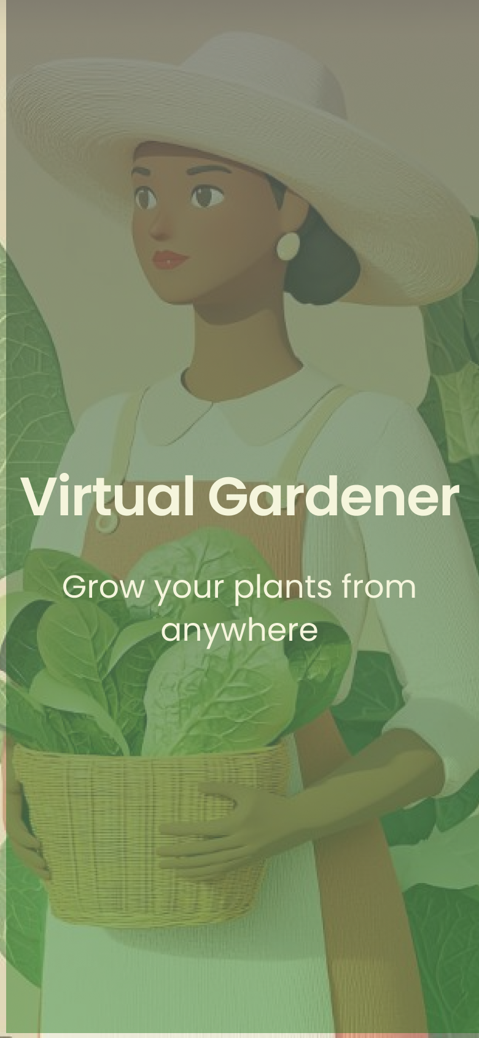**

**Screenshot of the Smell Sensor:**  
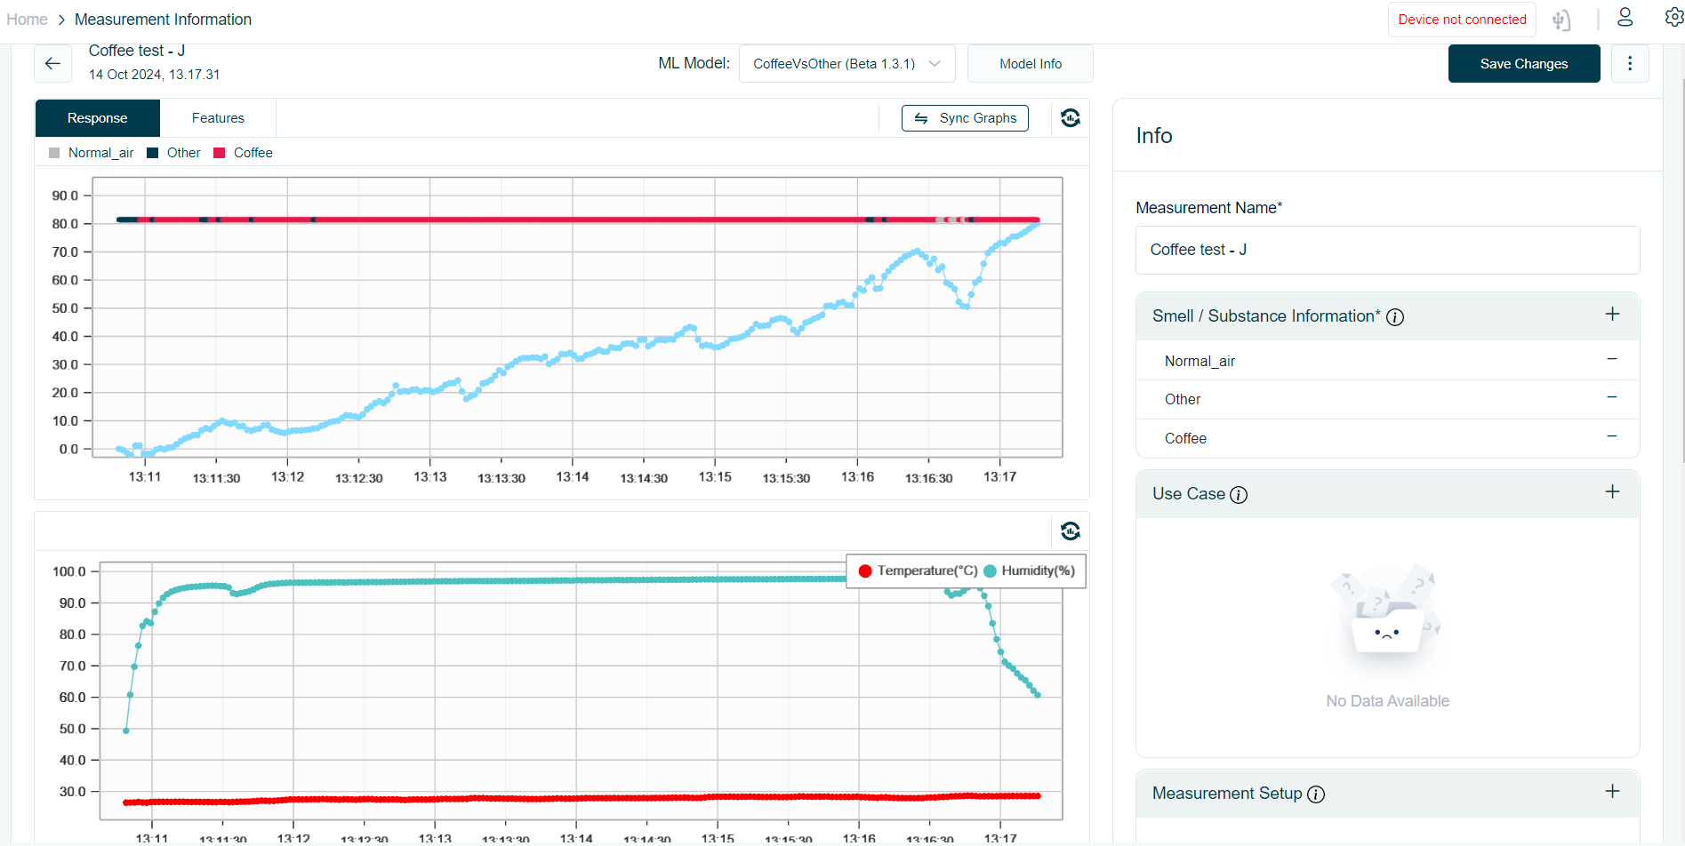

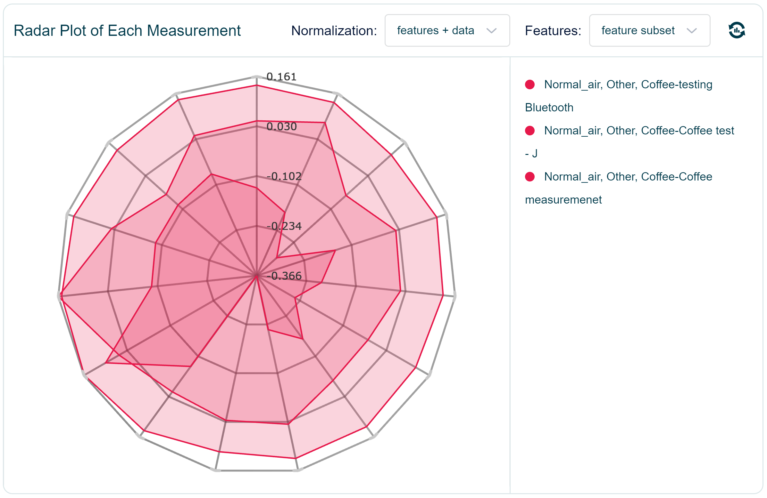

**GitHub issues:**

